**Operating System Lab**

**CS342**

Tanishq Malu Lab:5 1901CS63

**Q1.**

Pseudo-Code

Writer-code

do {

wait(wrt); // writer requests for critical section

// performs the write

// leaves the critical section

signal(wrt);

} while(true);

Reader-code

do {

wait(mutex); // Reader wants to enter the critical section

readcnt++; // The number of readers has now increased by1

if (readcnt==1) // Giving preference to reader even if one reader is present

wait(wrt);

signal(mutex);  // other readers can enter while this current reader is inside

the critical section

// current reader performs reading here

wait(mutex); // a reader wants to leave

readcnt--;

if (readcnt == 0) // If no reader is left in the critical section

signal(wrt); // writers can enter

signal(mutex); // reader leaves

} while(true);

Compilation:

g++ -o q1 q1.c -lm -pthread -fopenmp

Syntax:

./q1

Sample Input and Output:

Input:

g++ -o q1 q1.c -lm -pthread -fopenmp

./q1

Output:

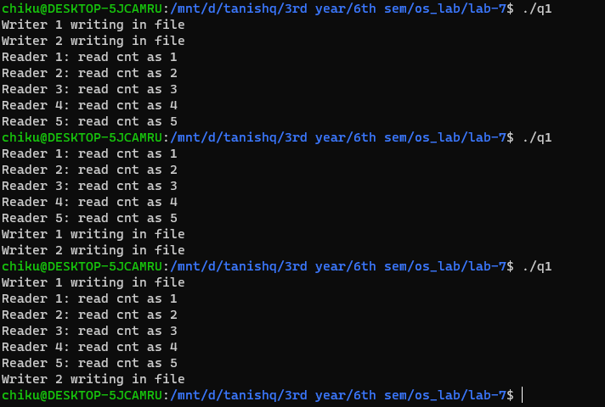

**Q 2.**

-------------------------------------------------- The End -----------------------------------------------